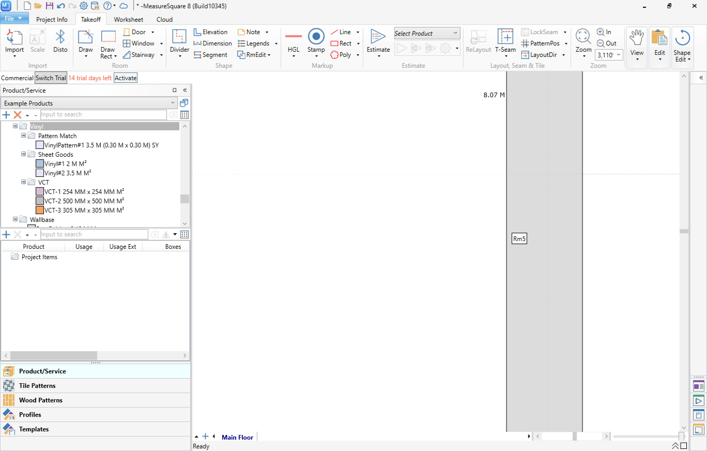

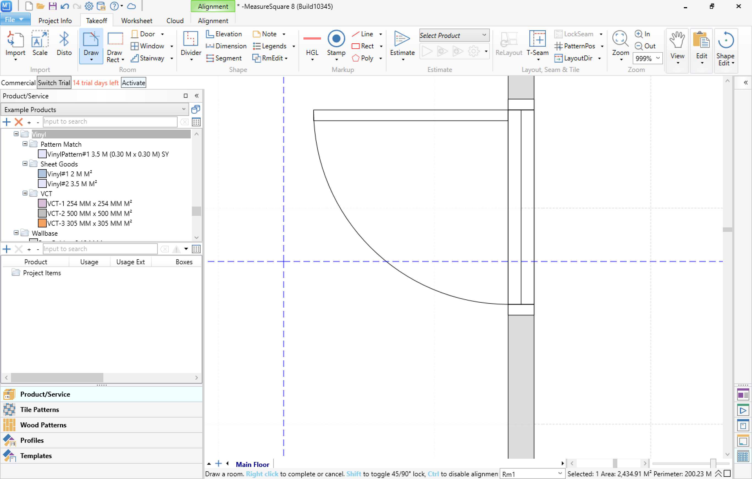

French doors

Slidinng

Folding door

**Double folding**

**Pocket**

